PFII/2004/WS.1/14

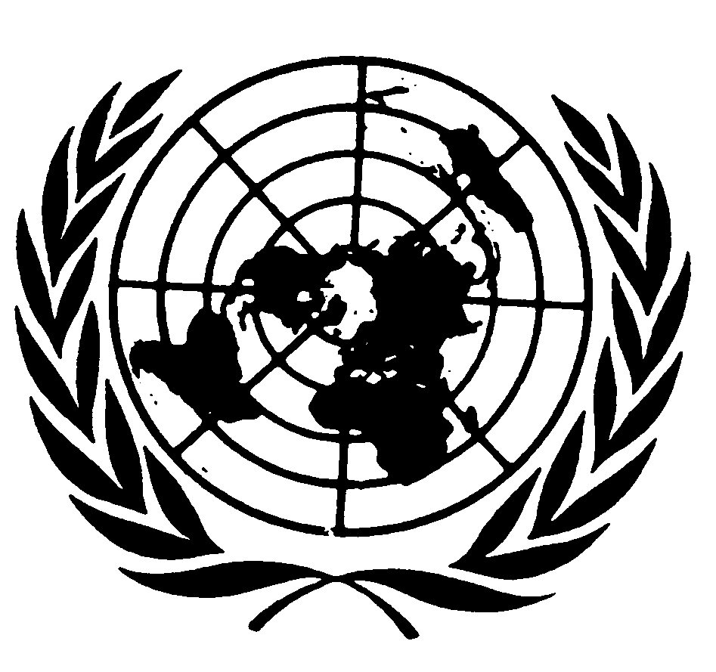
UNITED NATIONS NATIONS UNIES

DEPARTMENT OF ECONOMIC AND SOCIAL AFFAIRS
Division for Social Policy and Development
Secretariat of the Permanent Forum on Indigenous Issues

WORKSHOP ON DATA COLLECTION
AND DISAGGREGATION
FOR INDIGENOUS PEOPLES
(New York, 19-21 January 2004)

The perspective of information received and collected within the context of ILO Conventions Nos. 107 and 169, and other relevant ILO Conventions.

I Introduction

This paper provides a brief overview of the availability, types, sources and uses of data pertaining to indigenous and tribal peoples in those countries that have ratified either ILO Convention No. 107 or No. 169, highlighting the parallels and discrepancies, and the uses or limitations of the information available and the manner in which it is collected and applied. It is not an exhaustive survey. Ratifications of both Conventions are disproportionately higher in Latin America, and this must be taken into account when drawing information concerning different geographical regions. However, it can also be said that the amount of information available is least in the African countries that have ratified Convention No. 107.

In addition, some states engage in regular and extensive production of data on indigenous peoples, whereas for others, the collection of data is more sporadic and less systematic. Examples of systematic data collection in states include the annual Greenland Statistical Yearbook, the Report of the National Commission for Scheduled Castes and Scheduled Tribes of India, and the various reports and statistical information from specialised governmental and non-governmental institutions in Latin America. The data in these publications, however, often comes from other sources such as census sources and economic surveys, and may or may not necessarily be consistent from year to year in terms of the type of data gathered, and the way in which such data is disaggregated.

Where we indicate that certain types of data have not been submitted within the context of the application of Convention Nos. 107 and 169 in ratifying states, this does not mean to say that such data does not exist. It simply indicates that the data has not been submitted to the ILO as part of the supervisory process.

Data concerning indigenous and tribal peoples is not found only within the context of Conventions Nos. 107 and 169. The Forced Labour Convention, 1930 (No. 29); the Discrimination (employment and Occupation) Convention, 1958 (No. 111); and the Worst Forms of Child Labour Convention, 1999 (No. 182) are all of relevance to indigenous and tribal peoples, and data exists in this context that is of relevance to them. Reports on other ILO standards (for instance on labour inspection) have not yet been surveyed.

II Applicability

There is no definition of indigenous peoples in international law, though a “working definition” was proposed by a Special Rapporteur of the UN some years ago. Most of the participants in the discussions believe that a definition is neither practical nor advisable. ILO Convention No. 169 contains a statement of coverage and it also considers that self-identification be considered as a fundamental criterion for determining the groups to which the provisions of the Convention apply. (The ILO’s earlier Convention on the subject – Convention No. 107 – does not make reference to the principle of self-identification.)

Both Conventions Nos. 107 and 169 also stipulate that the scope of the measures to be taken to give effect to them should be determined in a flexible manner, having regard to the conditions characteristic of each country.

The lack of an international definition (though there are many national definitions), in addition to the vast differences between and within countries and regions in the situation of indigenous peoples, makes it difficult to apply one rule to data collection concerning indigenous peoples. Within the context of countries that have ratified ILO Conventions Nos. 107 or 169, for example, the scope of applicability of these Conventions varies considerably. Whereas some indigenous or tribal peoples may be defined by cultural characteristics such as language, etc., others may be defined territorially, or by descent. The principle of self-identification also plays an important role in some states in deciding to whom relevant Conventions should apply.

For example, in India, Convention No. 107 is applied to “scheduled tribes” who are defined in the Indian Constitution as “socially or educationally backward classes who have not yet been fully assimilated with the remaining sections of the population on account of being distinct from others in regard to their mode of living, customs etc.” In Norway, which was the first country to ratify Convention No. 169, in 1990, the Convention covers the Saami people. They are identified by the criteria of language, kinship and self-identification. They are not geographically defined, although most Saami live in just a few regions of the country. Other countries use criteria including geographical location to identify who are indigenous and tribal peoples. In short, there is no single way in which these peoples are identified by the states in which they live.

III Types of statistics available

It is very difficult to draw parallels between the types of statistics available on indigenous and tribal peoples in those countries that have ratified either Convention No. 107 or No. 169, due to the very different situations in the countries concerned, and the different criteria by which indigenous peoples are identified in the countries concerned. Both the types of data, and the availability and quantity of data vary greatly from country to country, and sometimes within countries. Often, data on more remote or inaccessible geographical areas (which is often where indigenous and tribal peoples reside) is less comprehensive.

The following is a summary of the data available, and is categorized on the basis of the information found, and does not necessarily follow the same format as the issues covered in ILO Conventions Nos. 107 or 169.

3.1 Socio-economic data

There is generally a lack of (both official and non-official) comprehensive documentation and disaggregated data on the socio-economic situation and income levels of indigenous and tribal peoples in all regions as compared to that of the rest of the population. Even though a number of Latin American countries have relatively extensive resources allocated for indigenous-specific development initiatives, there seems to be a lack of in-depth and contextualised socio-economic data on the livelihoods of indigenous and tribal peoples on the basis of e.g. household surveys.

3.2. Education

For ratifying states (Convention No. 107) in Africa, data on education tends to be primarily in the form of basic quantitative data on the provision of education services, and the resources allocated to such services. This tends to focus on such “positive” data (some of which is disaggregated by region, but very little, if any, is disaggregated by people/tribe/ethnic group). Other types of data in the area of education, for countries in Asia and Europe tends to be more substantial, and is often disaggregated by ethnic group, or disaggregated into two categories: indigenous/tribal peoples as one category and the national population (average) as another. This includes data on literacy rates, numbers of teachers in individual regions or in regions in which indigenous/tribal peoples form a majority, data on access to schools and educational facilities, and on trends in these categories over a short period of time (generally between 1 and 5 years).

One notable difference between data provided by states that have ratified Convention No. 107, and those that have ratified Convention No. 169, is the increased awareness in the latter, on the cultural aspects of education. In statistical data from Norway, for example, data on teaching in the Saami language and on bilingual education, as well as on the existence of education or training in traditional Saami handicrafts or in Saami culture is quite detailed. A similar picture exists for data concerning Greenland. In states that have ratified Convention No. 107, however, statistics do not make direct reference to indigenous languages or cultures, or the cultural appropriateness of education for indigenous and tribal children.

Most Latin American countries have relatively detailed information and disaggregated data on the number of indigenous and tribal peoples that have access to education services. Also there are many projects and programmes that specifically target the delivery of these services to the indigenous population. Where information on these is available, there is often data on the number of indigenous (intended) beneficiaries and the amount of resources allocated for the purpose.

However, in the Latin American context, there is still a lack of systematic and detailed information on the actual education situation among indigenous and tribal peoples and many countries lack detailed data on the amount of funding which the governments spend on indigenous education schemes relative to that spent on the population of the country as a whole. Information on specific measures taken to eliminate the inequality in the delivery of indigenous-specific education services and to ensure the respect for these peoples’ own languages, social and cultural conditions and traditional institutions and practices is often lacking in this context.

Hence, there is a need for more comprehensive data analysis in order to determine, for example, the quality of quantitative data (e.g. appropriate teachers for indigenous students and bilingual education); it would not be enough to state the number of indigenous persons who are either intended beneficiaries, have access to schools and literacy training, or are enrolled. Instead, it would be reasonable to look at the context in which these people are undertaking literacy training and to what extend it is benefiting their communities.

Some Latin American countries have specialised government bodies for indigenous education under, for example, the Ministry of Education. Also other government departments have disaggregated data on indigenous peoples. However, many national health policies do not yet specifically include the indigenous population, one of the likely reasons being the lack of disaggregated data and information.

Some Latin American governments do provide information on education centres established in particularly isolated and less accessible areas inhabited by indigenous communities at the preschool, primary school, secondary school and high school levels, but others state that it is often not possible to obtain data about schools and number of indigenous children attending schools in many disperse and isolated areas.

  - Health

Data in the area of health shows similar patterns. There is less data on health for ratifying states in Africa, and to a large extent in Asia and this data tends to focus on the provision of health services or the number of stationary and mobile health centres or hospitals built to accommodate both sedentary and nomadic peoples. However, in most cases this data is very general and is not disaggregated by ethnicity.

However, very little, if any, of these two regions’ data actually focuses on the health conditions of indigenous or tribal people – what is their health status, which are the diseases or health issues that affect indigenous peoples the most, and how these data compare with data in respect rest of the national population. States such as Norway have recognized this and indicated the need for better data in the area of health as a prerequisite to improving services.

It is interesting to note that, as with data on education, there is little reference in statistics concerning Convention No. 107 to indigenous peoples’ cultural practices and traditions in respect of health care, whereas for States who are party to Convention No. 169, this does constitute a consideration in some instances.

Some Latin American countries provide rather detailed official data on the access to health services disaggregated by ethnicity and even by age: indigenous children, youth, and adults. This includes information on the actual amount of government resources allocated per indigenous community for health services within indigenous territories. Many figures still reflect a disproportionately low amount of spending on indigenous peoples’ health relative to that of the total population.

In all countries there is a general lack of detailed disaggregated data and statistics on core health indicators such as mortality rates, life expectancy, illnesses, illiteracy rates (particularly among adults), educational level, etc. Also there is little information on the actual usage and effect of such health services provided among the indigenous population. This would be particularly useful in order to determine the effect and appropriateness of health schemes and not to rely exclusively on estimated data on intended beneficiaries or enrolment.

  - Land

For state parties to Convention No. 107, there is very little data on land issues, aside from data on resettlement arising from civil conflict or large development projects, populations inhabiting certain geographical regions, or land appropriation by non-indigenous persons from indigenous peoples.

Countries that have ratified Convention No. 169 often provide detailed information and data on land issues, including indigenous land tenure. There is both official and non-official data reflecting large areas of indigenous lands being in the possession of non-indigenous persons. Nonetheless, even though there is quite detailed data on the number of indigenous and tribal peoples inhabiting rural areas and often official information on land distribution (provided by population censuses and statistics), there seems to be a lack of specific and up-to-date information on the number of indigenous peoples in possession of their ancestral lands and territories relative to their number.

In some rural areas in Latin America, where the indigenous population often represents the majority of the population (more than 60 percent), the land that officially belongs to the indigenous peoples constitutes below 2 percent. Some countries are in the process of creating registries of indigenous lands and others have official data on both the extension of territories historically occupied by indigenous peoples and the titling of land (how many hectares, etc.).

  - Large development projects

There is often specific and extensive data - from both governments and NGOs – concerning the consequences of large development projects. The type of information on this subject differs considerable between regions. For African states, there is no such information. For Asian states, data primarily concerns resettlement and compensation related to large development projects, including such information as numbers of families resettled, earnings of resettled families, or land allocated to them, and the areas of such land allocated. This is, however, often not disaggregated by ethnic group, where such projects affect both indigenous and other populations. In addition, such data contains no indication of data collected prior to the initiation of such projects on their possible impacts, or concerning consultations with indigenous or tribal peoples in this respect.

Some Latin American governments provide detailed information on both the potential and ongoing effects that large development projects (e.g. hydroelectric dams) have on the indigenous peoples and their territories, while others lack such information, including the number of indigenous peoples affected. Such data is mostly based on surveys undertaken in the initial phase of the planning of the project. With this kind of information, there is a risk of having political and economic interests influencing data and the method of data collection. Consequently, the degree to which such data is based on both independent data collection and consultation processes involving the participation of the indigenous peoples concerned (as e.g. participatory appraisals) is often questionable. There is often detailed disaggregated data in cases of resettlement related to large development projects.

  - Development infrastructure

It can be said that generally, for all countries, there exists basic data on development projects implemented, and resources spent on such projects (for example, water sanitation, water pump installation, road construction, building of hospitals and schools) in areas inhabited by indigenous and tribal peoples. However, for some countries, this data is disaggregated by geographical area rather than by ethnicity, and other indicators such as needs in areas inhabited by indigenous and tribal peoples mostly does not exist. In spite of detailed data from Latin America, there is still a general lack of disaggregated systematic data on indigenous peoples’ access to, for example, clean water, sanitation and electricity.

  - Labour and employment

The ILO Bureau of Statistics annually gathers a wide range of labour statistics (and associated metadata) from countries of the world, but does not seek statistics classified by ethnic group in this data gathering. Consequently, the ILO database LABORSTA http://laborsta.ilo.org/ does not have any statistics classified by ethnic group. Nevertheless, the ILO has sponsored a large number of national surveys on child labour and many of these surveys have a question on ethnicity. Statistics (and in some cases even microdata) from these child labour surveys are available on the website http://www.ilo.org/public/english/standards/ipec/simpoc/index.htm

Within the context of information received under Conventions Nos. 107 and 169, data from Asia exists, disaggregated by state (originating from the said state governments) but not by ethnicity, on numbers of bonded labourers. Aside from this, for Asian and African states, there is little, if any information on employment or labour, with the exception of some data on the primary economic activities of indigenous and tribal peoples, and the percentage of these groups (as one category) employed in different economic sectors (such as agriculture, animal husbandry etc.).

In some Latin American countries there is relatively systematic information and disaggregated data on the employment situation of indigenous and tribal peoples. However, this often does not include data on indigenous peoples’ access to employment, employment rate, underemployment, unemployment, conditions of work, etc. There is also little official acknowledgement, hence data, of the importance of the informal economy in relation to indigenous and tribal peoples, of whom many are considered as self-employed (sometimes including even forest-dwellers, who have no relationship to the monetary economy). Because indigenous and tribal peoples are often involved in the informal or non-monetary economy, information on their situation is more difficult to get hold of.

In most countries, there is a lack of data and documentation on the conditions of work, particularly of indigenous migrant workers and agricultural labourers. This includes a lack of documentation on forced labour, bonded labour, and child labour affecting indigenous peoples. However, in other countries such as Paraguay and Brazil, there is more data available on these issues.

Within the context of Convention No. 111, limited data for certain countries exists on employment rates of indigenous peoples (including comparison with the total population), and the length of time spent in employment (Australia); on illiteracy rates of indigenous peoples and rates of access to skilled training and productive jobs or employment in Mexico; and other data on employment and occupation that refers specifically to indigenous peoples.

Within the context of the Forced Labour Conventions (Nos. 29 and 105) reference is made to the working conditions of indigenous peoples in quite a substantial number of countries. However, actual statistics are uncommon, or refer to specific cases or areas in which indigenous peoples are engaged in forced labour, and do not generally cover the whole national situation.

  - Human rights violations

Data concerning human rights violations comes from both governments and NGOs. For some countries who are party to Convention No. 107, there is extensive information on this – disaggregated by category of crime, region, and by ethnicity (as one category, but not disaggregated by individual groups). Most Latin American countries have disaggregated data (both governmental and non-governmental) on human rights violations against indigenous peoples.

IV Sources of statistics

Article 33 of Convention No. 169 stipulates that the governmental authority responsible for the matters covered in the Convention shall ensure that agencies or other appropriate mechanisms exist to administer the programmes affecting the peoples concerned, and shall ensure they have the means necessary for the proper fulfilment of the functions assigned to them. Convention No. 107 makes a similar provision in Article 27.

In many, but by no means the majority, states that are party to Conventions Nos. 107 and 169, there are regular, periodic data gathering exercises undertaken by government bodies responsible for indigenous and tribal peoples. These include the Report of the National Commission for Scheduled Castes and Schedules Tribes in India and the Greenland Statistical Yearbook (Greenland Home Rule Government). These data gathering exercises are, however, often based on data that has been collated from other sources, and not necessarily gathered originally with the specific intention of comprehensive analysis of the situation of indigenous and tribal peoples. Another problem with the use of data from various sources, is that different data sets are often incomparable, and the collection is often not systematic enough to be compared on an ongoing basis, for example, for analysing trends in certain areas.

Most of the statistics the ILO has concerning indigenous and tribal peoples in countries that have ratified Conventions Nos. 107 or 169, are from governments. For those ratifying countries whose governments have provided the ILO with statistics within the context of their regular reporting to the ILO under article 22 of the ILO Constitution, these statistics come from a wide range of sources, some of which have, but most of which have not been, collated especially for the purposes of reporting to the ILO, but existed otherwise. The most common source of data across countries is national population censuses, and other sources such as agricultural censuses, official government surveys on education and other subjects, economic surveys, and studies undertaken by government ministries or departments with competence in specific subjects. These data are then compiled within the context of reporting to the ILO.

A considerable amount also comes from NGOs, particularly in Asia, Europe and Latin America. Qualitatively, the data from NGOs tends to be of a different nature from that from governments, and primarily concerns alleged human rights violations. NGO data is primarily from Asia and Europe. Data from NGOs also appears primarily to constitute data collected by NGO representatives on fact-finding missions or missions of inquiry into specific cases or issues. No NGO data has been received from African states that have ratified Convention No. 107 (no African state has ratified Convention No. 169).

V Limitations and conclusions

The current status of data on indigenous and tribal peoples gathered within the context of the ILO’s supervision of Conventions Nos. 107 and 169 shows considerable disaggregation and documentation in about 60% of ratifying countries. In some countries, for various reasons, there is no data, and for others, data exists but it is unsystematic, and not disaggregated by ethnicity or even region.

There is generally a lack of systematic collection and documentation of disaggregated data on indigenous peoples on socio-economic development, education, health, land issues, large development projects, development infrastructure, labour and employment, and human rights violations.

As with all subjects, data from NGOs and Governments on issues pertaining to indigenous and tribal peoples often differs considerably both qualitatively and quantitatively. There is also little indication of the extent to which indigenous peoples have themselves been directly involved in the collection of data, and in the identification of the types of data that are most important to them. For example, indigenous peoples’ understanding of poverty, or land rights, often differs considerably from that of dominant or mainstream populations. This is rarely taken into account in the collection of relevant data.

There is very little information in all cases on the way in which the data concerned is actually used for policy or socio-economic development. The great variation in data sources also means that different sets of data are incomparable, as they are often based on different criteria or units and areas of measurement, and are therefore incompatible for purposes of comparison or collation. There is also very little, if any, information, on the methodologies used for collecting the data in question, with the exception of data collected within the context of missions undertaken to investigate specific cases.
Appendix: ratifications of Conventions Nos. 107 and 169.

I Ratifications of the Indigenous and Tribal Populations Convention, 1957 (No. 107) as of 1 December 2003.

Angola Haiti
Bangladesh India
Belgium Iraq
Cuba Malawi
Dominican Republic Pakistan
Egypt Panama
El Salvador Portugal
Ghana Syrian Arab Republic
Guinea-Bissau Tunisia

Denunciation (as a result of the ratification of Convention No. 169)

Argentina Ecuador
Bolivia Mexico
Brazil Paraguay
Colombia Peru
Costa Rica

II Ratifications of the Indigenous and Tribal Peoples Convention, 1989 (No. 169) as of 1 December 2003.

Argentina Fiji
Bolivia Guatemala
Brazil Honduras
Colombia Mexico
Costa Rica Netherlands
Denmark Norway
Dominica Paraguay
Ecuador Peru
Venezuela

This paper complements the powerpoint presentation by the ILO Bureau of Statistics under agenda item 1 of the workshop.
See appendix for a list of countries having ratified these Conventions, which is also the list of countries on which this paper is based.
This applies to: a) tribal peoples in independent countries whose social, cultural and economic conditions distinguish them from other sections of the national community, and whose status is regulated whole or partially by their own customs or traditions or by special laws or regulations; b) peoples in independent countries who are regarded as indigenous on account of their descent from the populations which inhabited the country, or a geographical region to which the country belongs, at the time of conquest or colonisation or the establishment of present state boundaries and who, irrespective of their legal status, retain some or all of their own social, economic, cultural and political institutions.

